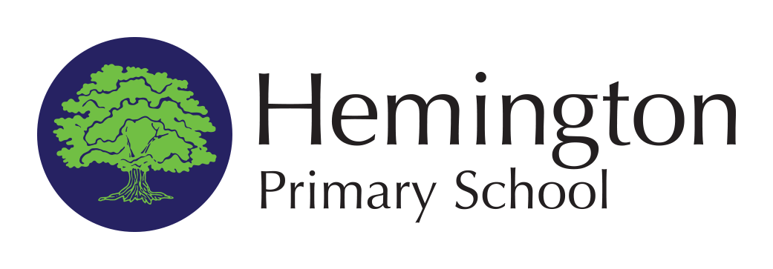

Hemington

Radstock

Somerset

BA3 5XU

01373 834320

Headteacher:

Alun Randell

**“To enable, encourage and equip all children to achieve their best**

**through an inspiring and nurturing environment.”**

Wednesday 18th September 2024

Dear Parents/Carers,

We will be taking Y1-Y6 children to see 'Robin Hood' at The Egg, Bath Theatre Royal on the afternoon of Thursday 5th December 2024. Please note that as this is an afternoon performance we will not be leaving the theatre until 4.20 pm, therefore, children will need to be collected slightly later than usual around 5.00 pm. Pupils will have their lunch slightly earlier at school and will need to bring a coat and water bottle.

The cost for the trip is £11.30 (Transport costs have been kindly funded by Wells Festival of Literature). Please can you return the permission slip by Friday 4th October 2024. Please can you also pay the voluntary contribution towards the cost of the trip on ParentPay by this date.

Best wishes

Lisa Pugsley

Administration Officer

Hemington Primary School

I give permission for my child/ren __________________________________________

to attend the Y1-Y6 School trip to ‘Robin Hood’ at The Egg, Theatre Royal Bath. I have paid the voluntary contribution on ParentPay.

Signed ___________________________________ Dated _______________________