LTP YR/1 Turtle Class 2024-2025
National Curriculum | EYFS | Term 1  2.9.24 - 25.10.24 | Term 2  4.11.24 - 20.12.24 | Term 3  6.1.25 - 14.2.25 | Term 4  24.2.25 - 4.4.25 | Term 5  22.4.25 - 23.5.25 | Term 6  2.6.25- 19.7.25
Events |  | RBA  Roald Dahl Day  Harvest  Black History Month  World Space Week 4-10/10/23  Pumpkin picking FG with Little Stars? | Halloween  Fireworks (wk 1 Tues)  Remembrance (wk 2 Mon)  Diwali  Children in Need | Lunar New Year 29.01.25  Internet Safety Day 11.2.25 | Shrove Tuesday 4.3.25  WBD 6.3.25  Red Nose Day 21 3.25  Dance Umbrella 25.3.25  Mother’s Day 30.3.25  Easter | Earth Day 22.4.25  World Turtles Day 23.5.24 | PSC Y1  EYP  World Oceans Day 8.6.25  Father’s Day 15.6.25
Themes and Vocabulary |  | Amazing You!  Belonging, special, feelings, emotions, community, where, who, home, likes and dislikes | Wonderful Weather  Weather, climate, seasons, Earth, North and South Poles, Equator, temperature | The Big Dig  Chronological, fossil  Prehistoric,million, evidence, artefact, significant, palaeontology | Awesome Animals  Habitat, diet, features, fish, amphibian, reptile, mammal, bird, warm-blooded, cold-blooded, herbivore, carnivore, omnivore | Where Are We?  Continents, country, Europe, United Kingdom, England, Wales, Scotland and Northern Ireland. Capital city, landmarks, human and physical features | Off We Go!  Continents, equator, China, Hong Kong, North, South, East and West. Tropical climate, beach, mountain, transport and tourism
National Curriculum | EYFS | 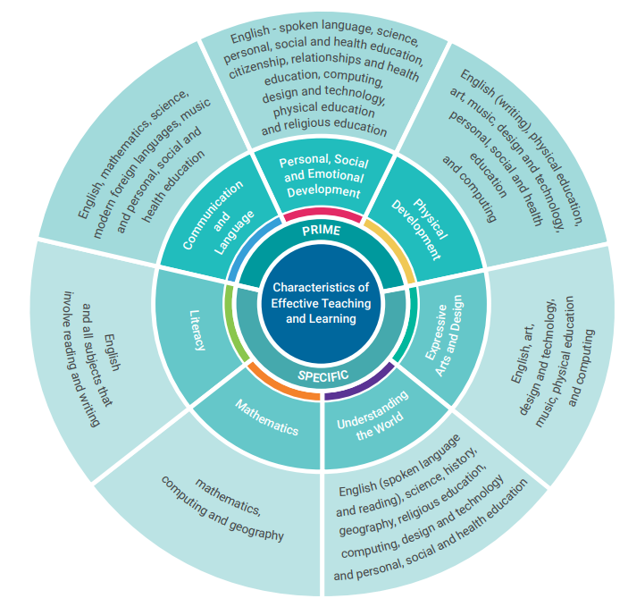
Phonics  Unlocking Letters & Sounds |  | YR - Phase 2  Y1 - Revise P4 | YR - Phase 3  Y1 - Phase 5a | YR - Phase 3 Mastery  Y1 - Revise Phase 5 Mastery | YR - Phase 3 Mastery  Y1 - Phase 5b | YR - Phase 4  Y1 - Phase 5c | YR - Phase 4 Mastery  Y1 - Phase 5c
English  Drawing Club | Communication and Language  Literacy | The Three Little Pigs  Ruby’s Worry  Smeds and the Smoos  The Colour Monster  Hansel and Gretel  Big Book of Colours  Oi Frog  The Colour Monster - Goes to School  Gingerbread Man  You Choose  Not a Box/The Dot  Little Red Hen  Funnybones | Firework Night Poem  Whatever Next!  Look Up!  Room on the Broom  Christmas Jolly Postman  The Snowman  Fireworks  Cbeebies Animation - Remembrance  Winnie the Witch  Diwali  Look Up!  Smed and Smoos  Raymond Briggs - Father Christmas/The Snowman and the Snowdog  That’s Not My Christmas Series | The Great Race  Little Red Riding Hood  Mr Wolf’s Pancakes  Are the Dinosaurs Dead, Dad?  Little People Big Dreams: Mary Anning  Koala Who Could  Three Little Pigs  The Great Race  LPBD - Mary Anning  The Fossil Hunter  Meet the Dinosaurs  Love Monster (Rachel Bright) | The Koala Who Could  Jack and the Beanstalk  Jasper’s Beanstalk  Supertato  Bill and Ben Flower Pot Men  Non-fiction?  Rapunzel?  Mr Wolf’s Pancakes  Rumble in the Jungle  Where the Wild Things Are  Holi Festival  Ada Twist Scientist  Perfectly Norman  Easter Story | Perfectly Norman  Rocket  Ada Twist Scientist  The Tiger That Came to Tea  Rumble in the Jungle  Three Billy Goats Gruff  Meesha Makes Friends  Jack and the Beanstalk (Jack and the Baked Beanstalk)  Jasper’s Beanstalk  Bill and Ben the Flower Pot Pen  Out and About (NF)  Paddington Series (UK, London) | The Snail and the Whale  Rainbow Fish  Pirates  If Sharks Disappeared  Goldilocks and the Three Bears (Sea Creatures)  Commotion in the Ocean  Clean Up!  The Proudest Blue  The Storm Whale  LPBD - Inspirational people - hobbies/interest  Transport?  The Lion Inside
Maths  White Rose  Number Sense Fluency  *Covered and revisited through out the year in provision* | Mathematics  Number Sense | YR - Subitising 1-3  Spatial Reasoning  Measures - size, weight  Y1 - Place Value (to 10) *Money, Measures - mass* | YR - Subitising 1-5  Shape  Patterns  Y1 - Addition and Subtraction (to 10)  *Geometry, Pattern* | YR - Subitising 1-10  Numerical Patterns  Measures - length  Counting out up to 10 items from a larger group  Y1 - Place Value (to 20)  *Measures - length and height* (Science link) | YR - Subitising 1-10  Partitioning 1-5 and 10  Numerical Patterns  Measures  Y1 - Addition and Subtraction (to 20)  Place Value (within 50)  *Mass and Volume, Money* | YR - Composition 6-9  Measures  Number bonds  Y1 - Place Value (within 50)  Y1 - Multiplication and Division  *Measures - Length and Height (Plants link)  *Geometry - Position and Direction* (Geog link) | YR - Patterns in Numbers  Shape  Number bonds  Y1 - Place Value (within 100)  Fractions  Time  *Money*
Science | Understanding the World | Animals including humans ( Animals and Humans) | Seasons and Weather (Also to be taught through out the year as seasons emerge). | Everyday materials and their uses  (substances and properties) | Animals | Plant Detectives (Plant Life) | Everyday materials and their uses 2
PE  EYFS/KS1 1 of each or x2 EYFS for 3 then x2 KS1 for 3 | Physical Development  Expressive Arts and Design  Personal, Social and Emotional Development | EYFS - Introduction to PE 1 (Indoor)  KS1 - Ball Skills (Outside)  Dance MR  Fundamental 1 | KS1 - Dance (Indoor) MR  EYFS - Fundamentals 2  Yoga  Gymnastics  Nativity - Dance | EYFS - Gymnastics (Indoor)  KS1 - Invasion Games (Outdoor)  Football  Games 2 | EYFS - Games 1  KS1 Fitness  Football?/Invasion Games  Target Games | EYFS - Ball Skills 2  KS1 - Net and Wall Games (Outdoor)  Net and Wall Games  Fitness | KS1 - Athletics (Outdoors)  EYFS - Dance (Indoor MR)  Striking and Fielding  Athletics
Computing | Maths, PD, UtW, EAD, PSED | Computing systems and networks – Technology around us | Creating media – Digital painting | Creating media – Digital writing | Data and information – Grouping data | Programming A – Moving a robot (Geography link/Maps) | Programming B - Programming animations (animals link)
Art/DT  Kapow - Seasons projects to support Geog/Sci | Expressive Arts and Design, Physical Development, PSED | Painting and mixed media: Colour Splash  EP - EYFS Kapow  Each term use EYFS  Painting - Paint my world for EP each week | Craft and Design: Woven Wonders (Art) - Weaving/threading poppies. Christmas trees/stockings - weaving/fine motor links (Replace Sculpture). | Structures - constructing a windmill | Textiles - Puppets - Easter Animal Theme  DT - Retrieval - moving books/sliders for WBD books  *Moving sliders Christmas Cards 25/26 | Drawing: Make Your Mark (Link to animals (Science) - patterns/footprints reflect on T4)  Link to plants - observational drawings etc | Cooking and Nutrition - Smoothies
History/Geography | Understanding the World | Memory Box Changes within living memory.  common words and phrases relating to passing of time.  History EY Links:  - Key concept of the past and past events.  - Know the terms past and present.  Toy Story/Old Bear | Wonderful Weather  Climate/weather in UK and the world -  (Also taught as Seasons emerge) | The Big Dig Dinosaurs and Mary Anning - life of a significant individual, common words and phrases relating to passing of time. Understand how we find out about the past. Know history as coherent narrative  CBBC Deadly 60 Beasts?  The London Museum Mary Anning clip.  Padlock of dates to open clues etc. 1 each week? | Communication over time: Changes in living memory  lives of significant individuals who have contributed to national and international achievements: William Caxton and Tim Berners-Lee.. | Bright Lights Big City  Where is the UK? Capital Cities? Comparison between Somerset and London (take them into Bath/Bristol Open Top Bus Tour?)  Recycling - looking after our world  Earth Day and sustainability | Local Area & Hong Kong  Where? What does it look like? Transport? Live? Comparison
Religion and Worldviews | Understanding the World, PSED | Christianity - Creation | Christianity - Incarnation 1-4  Fireworks, Remembrance, Diwali, Christmas | Christianity - Incarnation 5-10  Lunar New Year | Christianity  Easter  Holi Festival | Judaism | Judaism
PSHE | PSED, CL | Being Me In My World | Celebrating Difference | Dreams and Goals  New Year | Healthy Me | Relationships | Changing Me
Music | EAD, CL | Listening - Hey You! | Nativity/Christmas | Listening - Rhythm In The Way We Walk & Banana Rap | Listening- In The Groove | Listening - Round And Round | Listening - Your Imagination

