  English: Writing   | English: Reading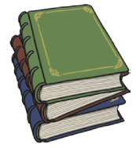 | 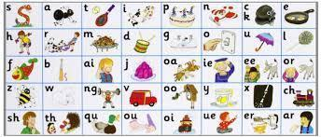  Phonics | Maths   | Science  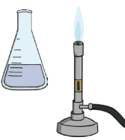 | History  
Key writing skills  - Oral retelling of a traditional tale  - Innovating story maps and sequencing stories  - Applying phonics when spelling for labels and sentences  - Using finger spaces between words  - Using full stops  - Using a capital letter at the start of a sentence and the pronoun ‘I’  We are writing:  - Narratives linked to our class book ‘The Three Little Pigs’ | Books we will read  - Mixed Up Fairy Tales by Hilary Robinson and Nick Sharratt  - The True Story of The 3 Little Pigs by Jon Scieszka  - The Three Little Wolves and the Big Bad Pig by Eugene Trivizas and Helen Oxenbury  Poems we will read  - A daily seasonal poem from the anthology: The Seed that Grew The Tree  Additional texts  - Guided reading books linked to specific phonics | Phonics focus  - Phase 3 and Phase 4 review  - Recognising and spelling common exception words  - New Phase 5 digraphs | Place Value (within 10)  - Counting objects from a larger group  - Recognising numbers as words  - Counting on from any number  - 1 more and 1 less  - Less than, greater than, equal to  - Ordering objects and numbers  - The number line  Number Sense: Visual number foundations:  - Subitising quantities 1-5  - Subitising structured arrangements for quantities 6-10  - Recognising quantities 1-10 twos- wise and fives-wise on a tens frame | Everyday Materials  - Identifying everyday objects and materials  - Describing and group materials by properties  - Deciding on suitable materials based on properties  Working Scientifically  - Investigating the most suitable material for a teddy’s umbrella (fair testing)  Seasonal Change  - Observing our special tree (observing over time)  - Investigating Autumn | The Great Fire of London  - Historical artefacts  - Similarities and differences between past and present London  - Timeline of events  - How do we know about the fire?  - Significant figures - Samuel Pepys  - Tudor Houses  - Changes after the great fire.
Music  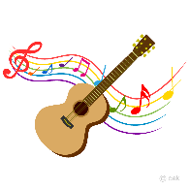 | PE   | Computing   | PSHE  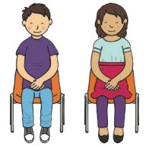 | RE   | Art/DT  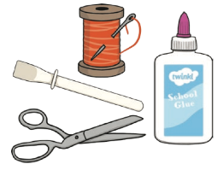
Pulse  - Finding the pulse  - Singing a sound pattern  - Using a thinking voice  - Reading sound patterns  - Using pulse in performance | Fundamental skills  - Developing agility, balance and coordination with sprinting, jogging, throwing etc | Technology Around Us  - Identifying technology  - Identifying a computer and its main parts  - Using a mouse  - Using a keyboard to type and edit text  - Rules for technology responses | Being Me in My World  - Feeling special and safe in class  - Creating a learning charter  - Feeling proud of an achievement  - Recognising a range of feelings | Christianity  - What do Christians believe about God? | Drawing and Painting  - Exploring line  - Experimenting with media  - Mark making  - Drawing from observation  - Painting

